Part 2: Our chapter’s interactions in our campus community

Participation in Local SPS Meetings
Did your chapter meet regularly this year? | Yes No
How Frequently? | Weekly Bi-Weekly Monthly Quarterly
About how many people attended?  What is your Chapter’s budget? | 10  $1500 (per academic school year)
Do you fund raise? | Yes No
Do you receive funds from your school? | Yes No
How many people are SPS National members? | 12

- Many of our SPS meetings this past year revolved around attendance to the Quadrennial Physics Congress in November 2016, as well as focusing on getting more physics students involved in SPS. We made our meetings more well-known than we had before, and we came up with newer, more fun events for people to look forward to. We discussed various fundraising ideas to help with the costs associated with PhysCon, while maintaining that interest in participation and never forgetting the physics. We did a few bake sales and some profit sharing through local businesses and restaurants. At our meetings in the fall, we had discussed last-minute fundraising for the congress. The spring semester showed some transitional movement for the upcoming graduating officers, such as Jamie Stafford and John Pickren. Needless to say, the other officers and members stepped up to help keep events and meetings going and to make sure that our potential new officers would be kept “in the loop” for the next semester. We still wanted to focus on keeping people interested and wanting to get involved in our fundraising and social events. Since last year, when the 2015-2016 officers were elected, we have nearly doubled the amount of regular member attendance and SPS national members, which is a huge accomplishment for a small organization like ours.

- As part of our goal to recruit new members and spark interest in SPS, our 2015-2016 secretary, Daniel Dove, offered minutes of SPS meetings via email to all SPS members and interested students (physics and non-physics majors).

Chapter Social Events
- On several Tuesday evenings, our SPS chapter hosted a game night whimsically named “Physics After Dark” where members, friends, faculty, and staff got together and played different games and socialized with each other.
  - On occasion, instead of a game night, members would attend a movie at the local theater in town. We also had a group go to the South Texas State Fair together this spring where they enjoyed live music, rides, and a variety of festive foods.
- In May, several members, faculty, staff, family and friends attended a local Mediterranean Festival while taking a break from studying for finals. They enjoyed live music and dancing, shows, a bazaar, and tons of food!

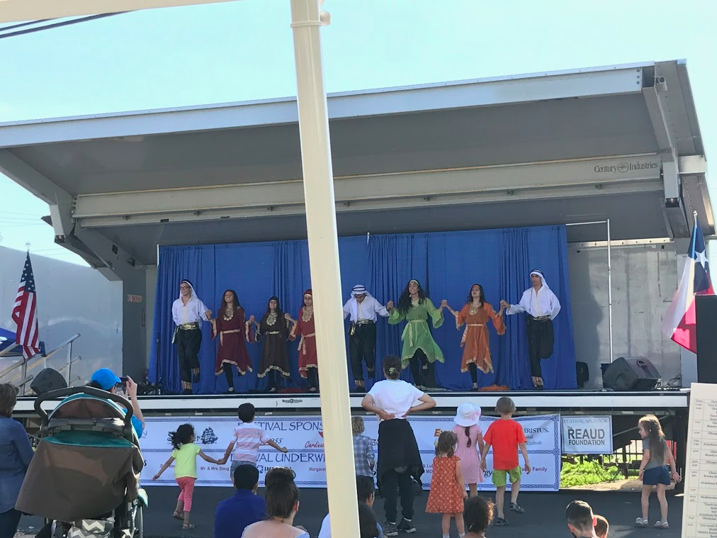
Figure 4: One of the shows at the Mediterranean Festival.

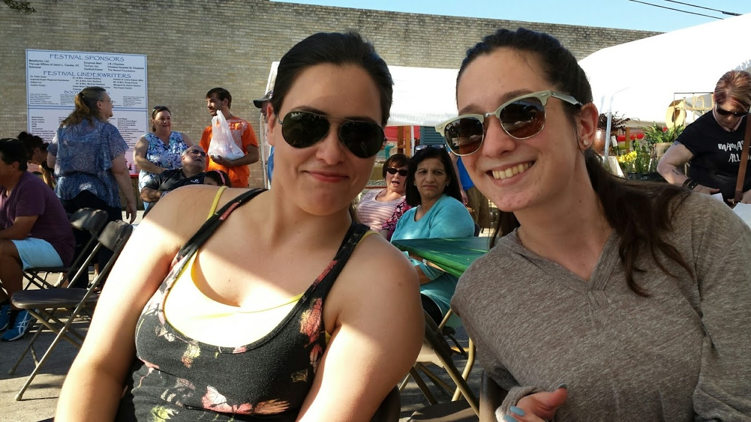
Figure 5: Suzanne Wheeler and Jamie Stafford take a selfie while at the Mediterranean Festival last May.
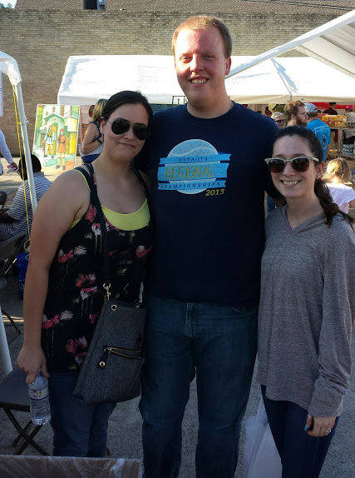
Figure 6: (left to right) Suzanne Wheeler with John Pickren and Jamie Stafford during the Mediterranean Festival.
- To celebrate several of our graduating members, we held a Graduation Party on May 9th, 2017 at Tyrrell Park. We grilled burgers and hot dogs and enjoyed one another’s company for one last time before the summer. Members also played Washers and threw around a frisbee while the sun set.
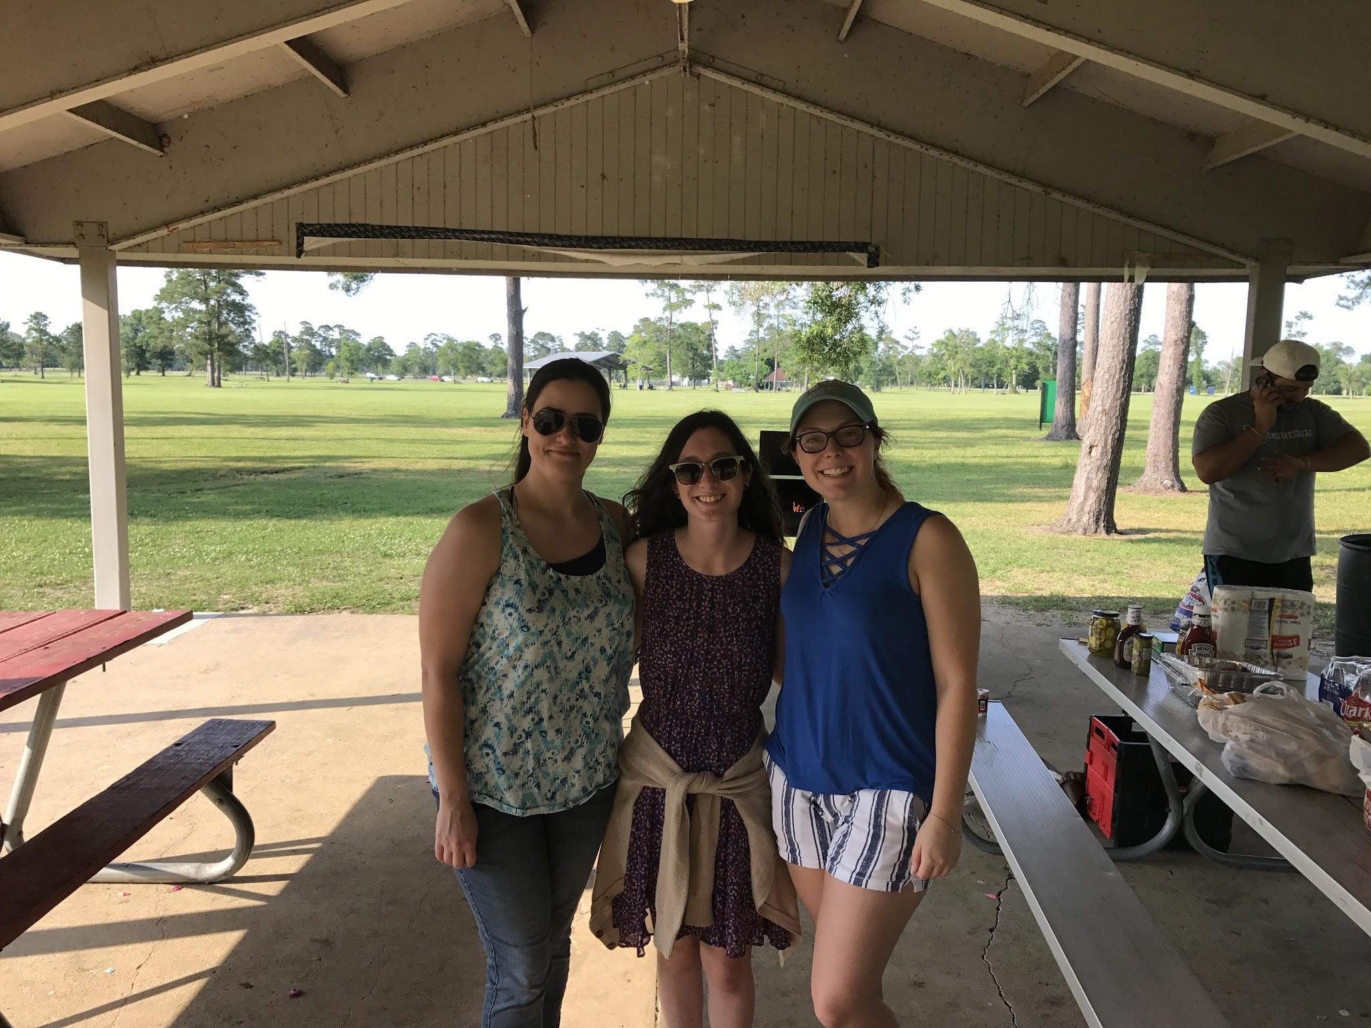
Figure 7:(from left to right) Suzanne Wheeler, Jamie Stafford, and Bonnie Ruten pose for a photo at the graduation party.
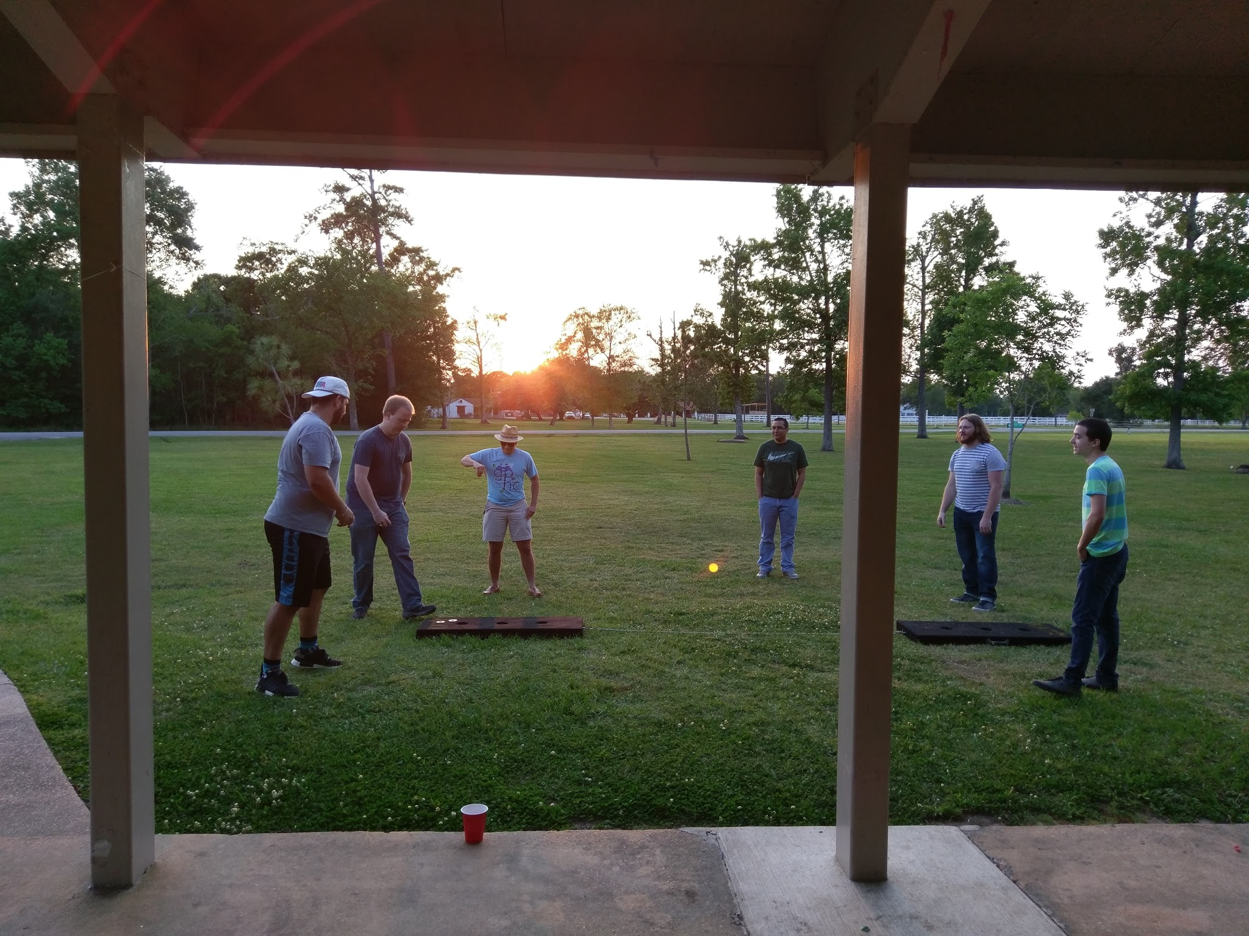
Figure 8:Members who attended enjoyed a couple rounds of Washers after their burgers and hot dogs. (from left to right) Christian Dick, John Pickren, Carlos Caballero, Luis Romero, Alek Hudson, and Derek Dixon.

Participation to On Campus Science Events
- Every October, the Office of Undergraduate Research organizes a conference for STEM students at Lamar University, in the state of Texas, and some neighbor states. Three SPS members gave presentations at the Texas STEM conference held at Lamar University on October 29, 2016. Suzanne Wheeler and Zakary Noel presented “Polarized Light Emitted by Glowing Objects Can Reveal Their Shape”. John Pickren was not able to attend the conference because the Physics GRE was scheduled at the same time in Houston. His poster was on display however, with the title “Finding Impurities in Medicines and Flare Towers Using Spectral Analysis”.
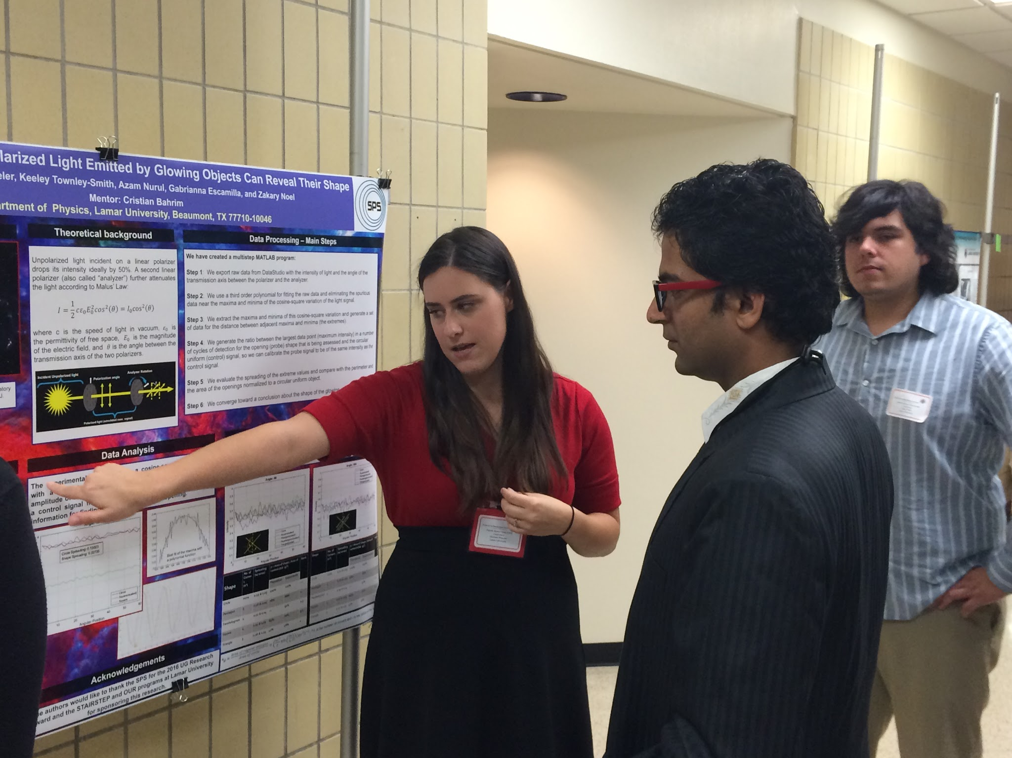
Figure 9: Suzanne Wheeler and Zakary Noel presenting their poster titled “Polarized Light Emitted by Glowing Objects Can Reveal Their Shape” at the Texas STEM Conference at Lamar.

- In November 2016, three SPS members received research awards from the Office of Undergraduate Research at Lamar.
  - Suzanne Wheeler, a physics and mathematics major, for the project “Finding the Composition of Selected Medical Plants using Spectroscopy of Absorption.”
  - Emily Ochoa, a chemical engineering major, to study “an implementation of Perl scripting language as a wrapper in simulations of manganese oxides.”
  - Aaron Phillips, a physics and mathematics major, to study “Thor Sequences as a Platform for Interaction Between Relations and Their Components.”
Figure 10: (left to right) Emily Ochoa and Suzanne Wheeler after receiving research awards from the Office of Undergraduate Research.
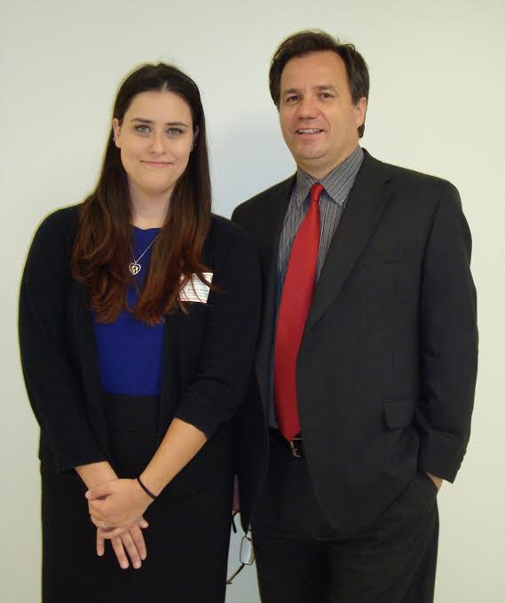
Figure 11: Suzanne Wheeler with her mentor Dr. Cristian Bahrim.

