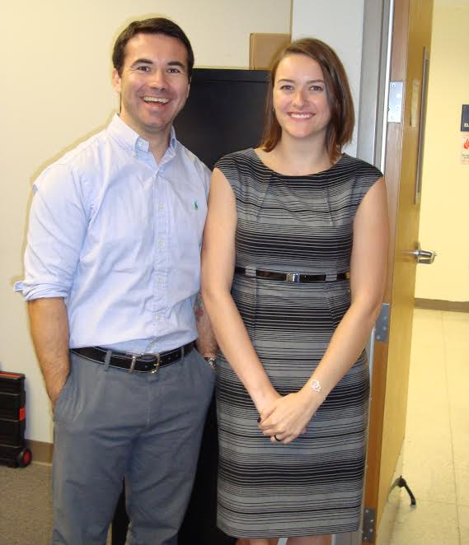
Figure 12: Emily Ochoa with her mentor Dr. Cengiz Sen.
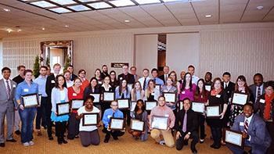
Figure 13: All recipients of the 2016-17 Office of Undergraduate Research Award
- In 2016-2017, Suzanne Wheeler and Aaron Phillips are participating with independent projects in the Ronald E. McNair Scholars Program. The McNair Scholars Program is for underrepresented, low-income, or first-generation college students. The program demands that students complete a literature review, conduct independent research over the summer and then defend their work orally in the fall. Suzanne’s proposal is entitled: “A Novel Tool to Illuminate the Role of Gluons in the Production of Subatomic Particles.” Suzanne’s faculty mentor is Dr. Jim Drachenberg. Dr. Drachenberg works with the STAR collaboration at Brookhaven National Lab (BNL).
- On April 21, 2017, Lamar held the fourth Annual Undergraduate Research EXPO sponsored by the Office of Undergraduate Research.
  - Suzanne Wheeler presented a poster titled: “Work in Progress: Finding the Composition of Selected Medical Plants through Spectroscopy of Absorption,” (mentor Cristian Bahrim).
  - Zakary Noel gave a talk titled “A New Method to Determine the Shape of a Glowing Object: Departure From a Regular Signal Driven by Malus' law,” with co-authors Gabrianna Escamilla, Daniel Dove, Suzanne Wheeler, and mentor Cristian Bahrim.
  - Aaron Phillips gave a talk titled “Thor Sequences,” with faculty mentor Dr. PJ Couch in the mathematics department.
  - Nic Nikoloutsos presented a poster titled: “The Therapeutic Potential of Cannabinoids in Alzheimer's Disease” with faculty mentor Dr. Maryam Vasefi in the biology department.
  - Carlos Caballero gave a talk titled “Work in Progress: Materials Mechanical and Thermo-Electrical Properties' Role in Aerospace Applications and their use for Active Flow Control,” under mentor Cristian Bahrim.
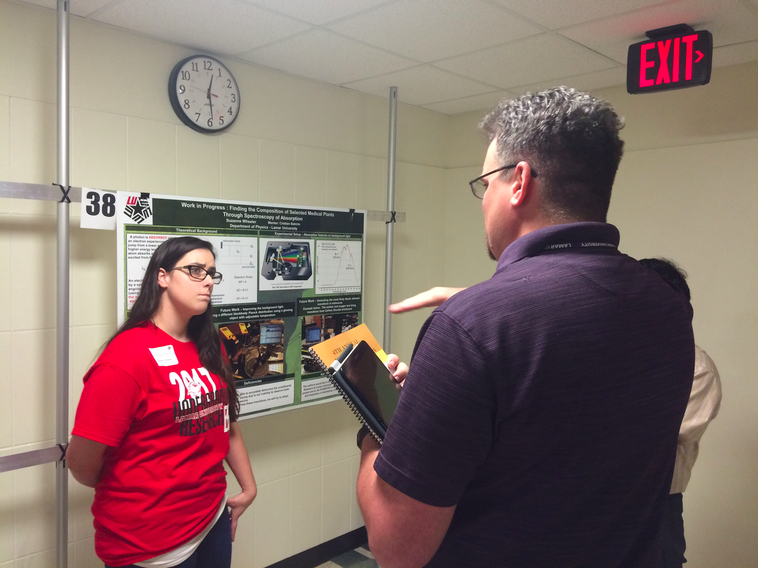
Figure 14: Suzanne Wheeler presenting at her poster “Finding the Composition of…” at the Annual Undergraduate Research EXPO.

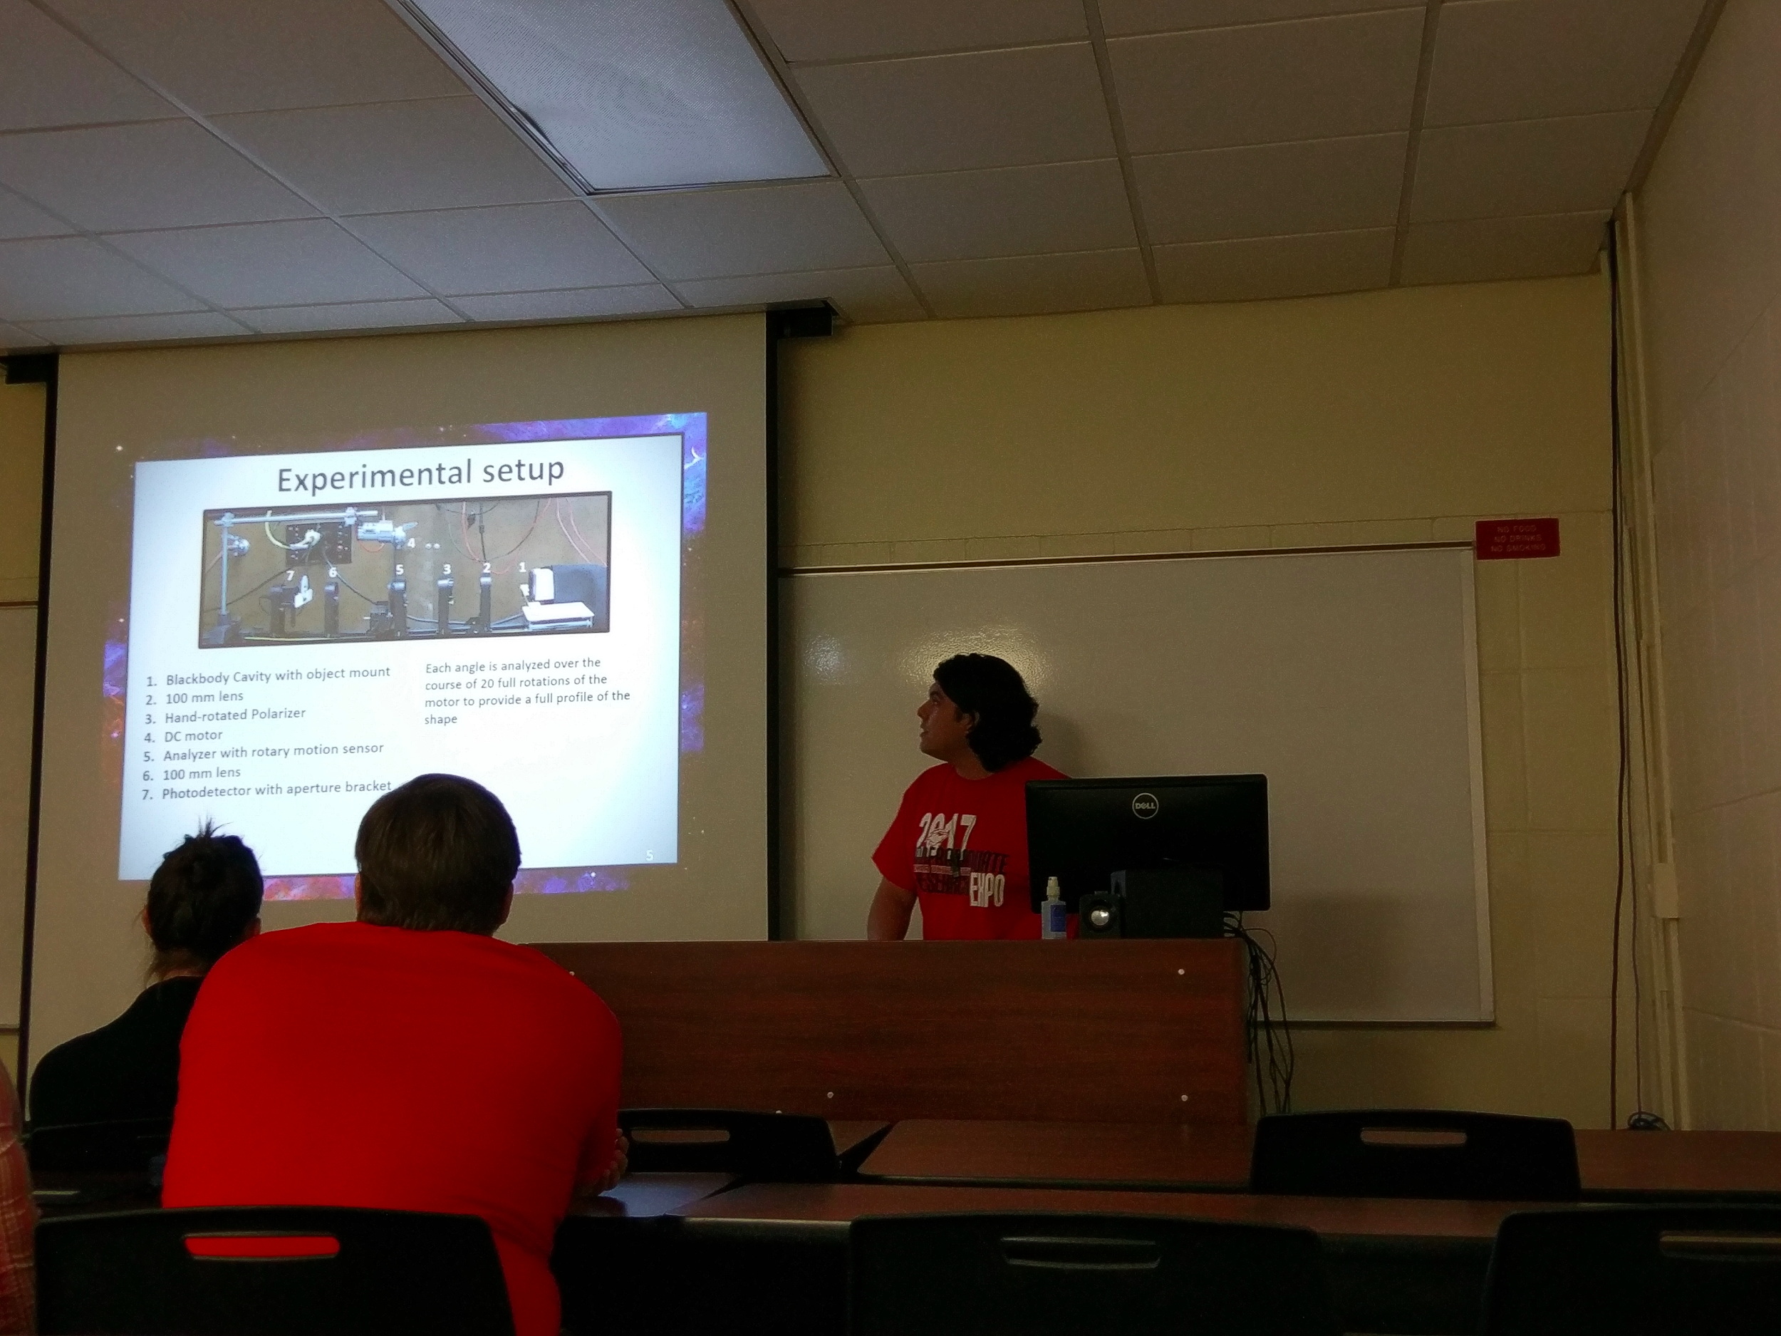
Figure 15: Zakary Noel presenting his talk titled “A New Method…” at the Annual Undergraduate Research EXPO.

Participation to On Campus Science Outreach
- In June of 2016, SPS members Suzanne Wheeler, John Pickren, and Azam Nurul assisted SPS advisor Cristian Bahrim and Lamar University faculty member Tela Urbina in the Bernard Harris Exxon Mobil summer camp. The physics students helped with the egg drop activity and media day. This was a summer camp for middle school children that excel in their studies, but do not have adequate financial resources to participate in camps like this one. The students were put into six teams supervised by Exxon Mobil engineers. They designed a “lander” that could safely hold and “land” an object falling from a significant height. They competed against each other to see who had designed the best lander, while learning about the science behind it. Our SPS members Suzanne, John, and Azam, and Dr. Cristian Bahrim taught the students about the physics concepts behind the experiment and led the testing part of the lesson.
- Lamar University hosts a New Student Orientation on multiple weekends during the summer from July through August. The Office of Student Organizations at Lamar hosts a Resource Fair during these weekends for student organizations such as SPS to get a head start on recruiting new students. We took part in this during 2016 and have registered again for the summer of 2017.
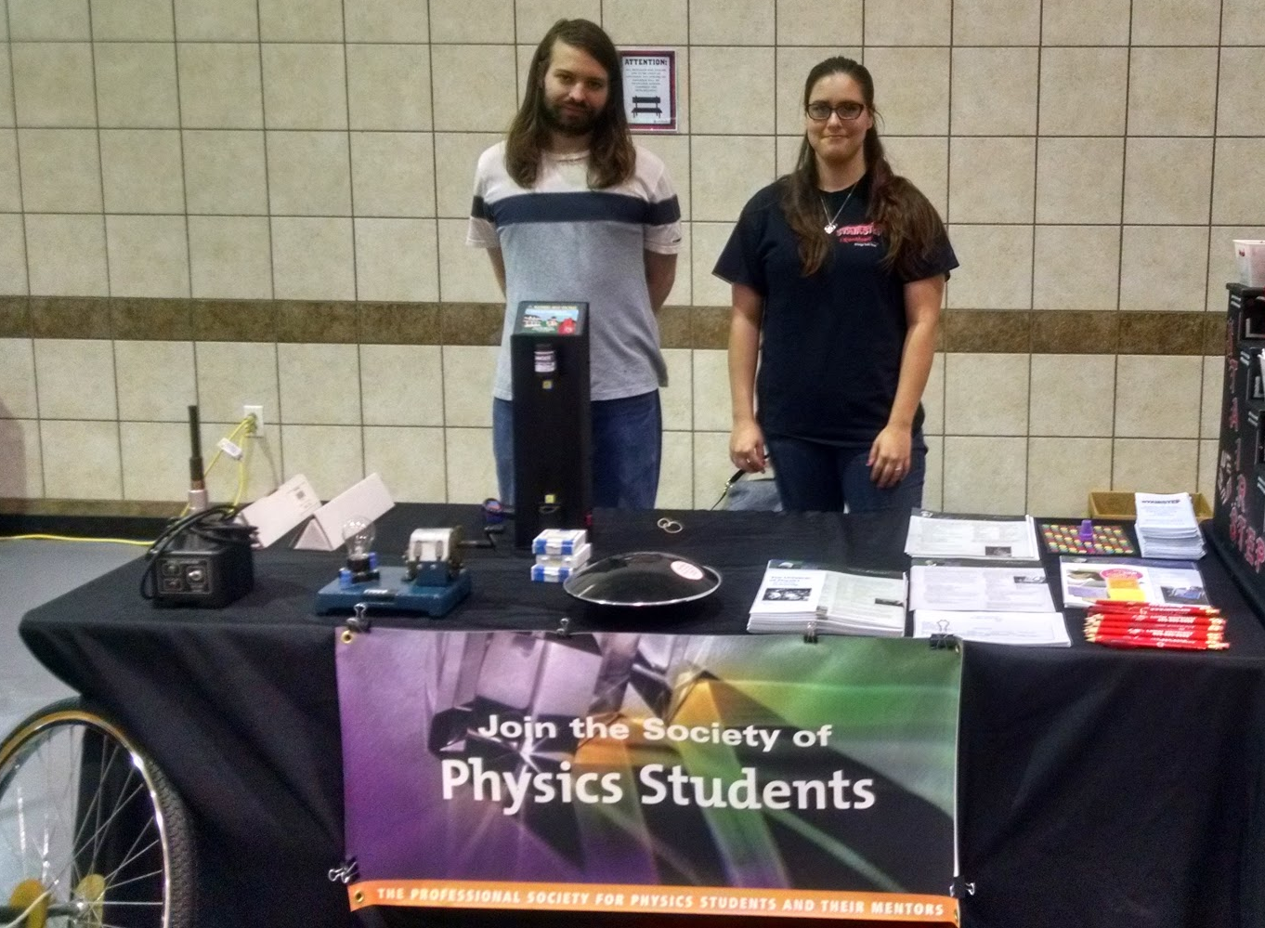
Figure 16: SPS Members Craig Street and Suzanne Wheeler man the table for the New Student Orientation Resource Fair.
- In the summer of 2016, the Reaud Honors College hosted a summer reading club. Our SPS advisor, Dr. Cristian Bahrim, proposed the book: "Hyperspace" by Michio Kaku. Several Lamar students participated, including SPS member Carlos Caballero. The students read and discussed the book’s topics and at the end of the summer, put together a presentation about an aspect they found interesting from the book.

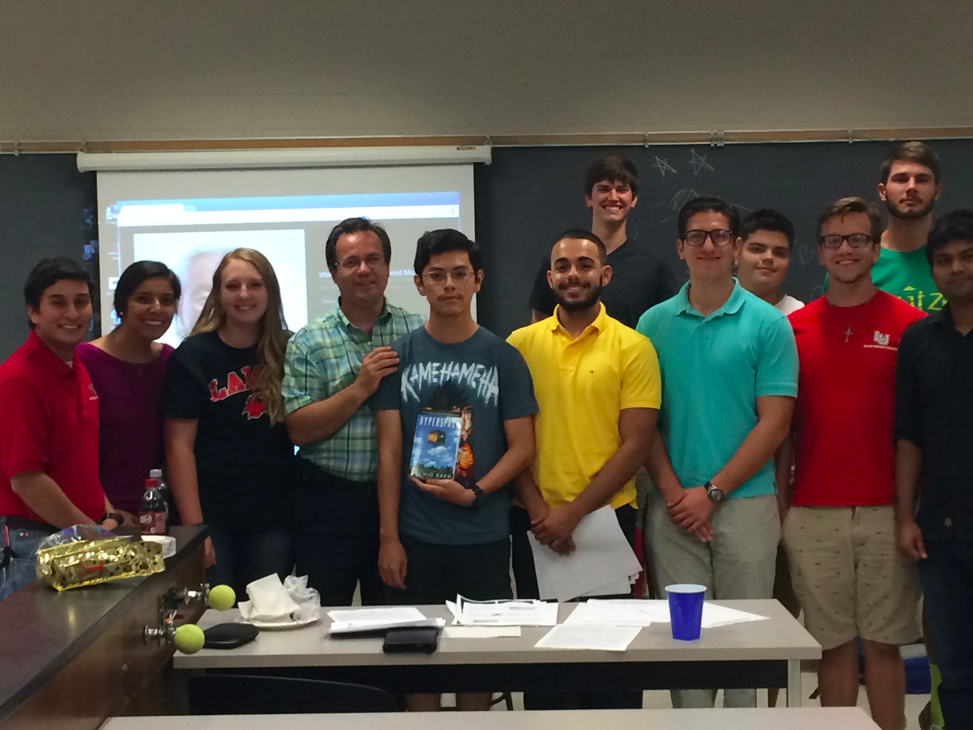
Figure 17: Students who were involved in the Reaud Honors College Summer Reading group pose with Dr. Bahrim for a group photo.
- Paul Rizk - June 27, 2016, a Lamar physics Lamar alumnus now at the Medical School at UT Dallas in Fort Worth discussed with a few members what life outside of academia is like and how his physics degree has helped him in medical school.
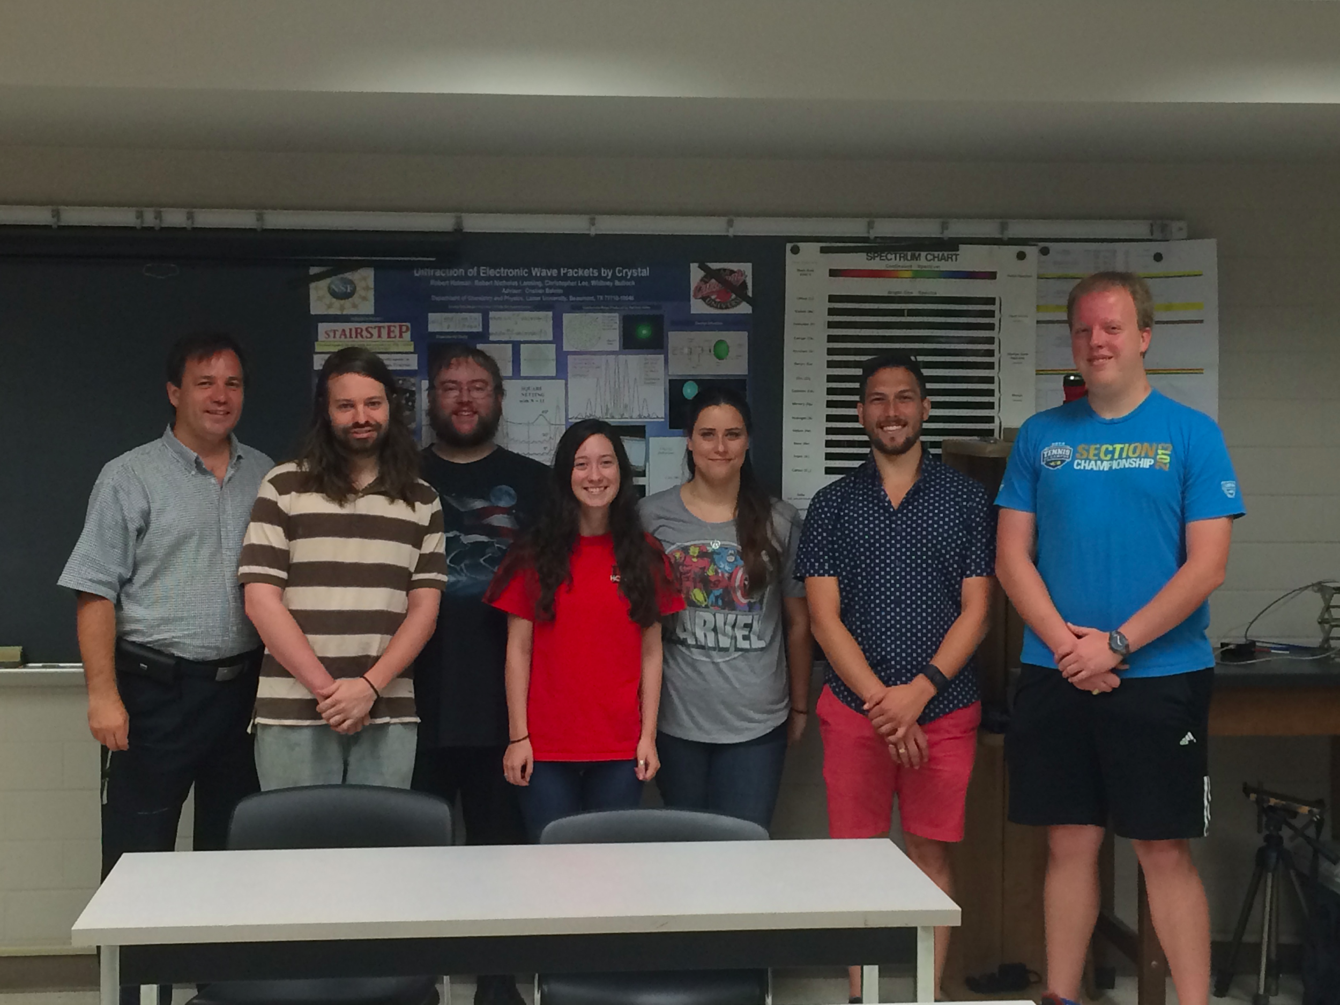
Figure 18: (from left to right) Dr. Bahrim, Craig Street, Daniel Dove, Jamie Stafford, Suzanne Wheeler, Paul Rizk, and John Pickren.
- In January 2017, Keeley Fairchild, a Lamar alumna, now in graduate school at the Institute of Optics, visited with a few students about the SPS Polarization project and her life in graduate school.

